**Te Kura o Hau Karetu**

He waka eke noa: *We’re all in this waka together*

32 Hillside Drive, Māoribank, UPPER HUTT 5018

Phone (04) 5269-552, 027-5269-552

Email: office@tehaukaretu.school.nz

**11th April 2024**

Kia ora, Talofa Lava, Mālō e lelei, Kia orana, Namaste, Kumusta,

**Nau mai, haere mai/welcome** to our new students Zairus who is in Te Waipuna, and Poorvi who is in Te Pūao. We are delighted to have you at our kura/school.

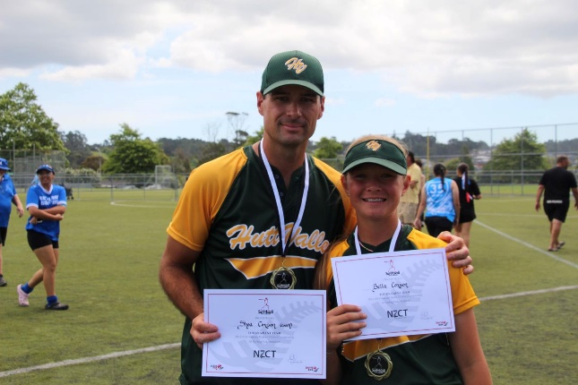

**Golden Staff Member:** This week, we would like to celebrate and congratulate Matua Shea who has been nominated for Volunteer of the Year and Domestic Coach for Softball NZ. Shea, we are incredibly proud to have you as part of our team. I know how lucky we are to have you as our Tumuaki Tuarua/Deputy Principal, and Softball NZ are also very lucky to have your talent in their midst. We are crossing our fingers and toes for the nominations!

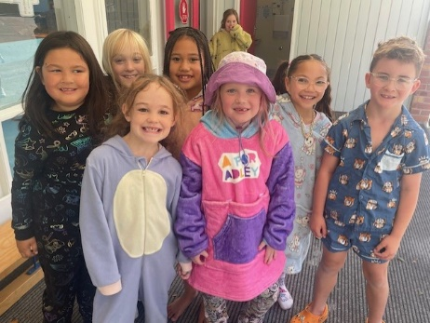

**Golden Children:** Te Awa have earned a class party and today they are dressed up in their pyjamas and are sharing a feast. Congratulations Te Awa who have been showing their WAKA values and earning heaps of Dojo points!

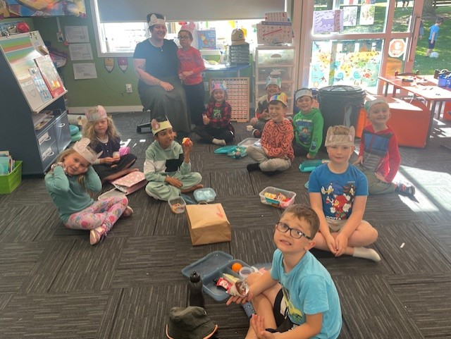Te Hikuwai have created mouse hats today. They are practising being as quiet as mice. Every time they are quiet, they receive a piece of “cheese” and then earn more dojo points. They all had to say “cheese” when I took the photo, because that’s what mice love to eat! 😊



**Netball** - We are rapt that there are so many ākonga/students who have chosen to play netball this year. We have the most teams we’ve ever had, but of course we require your support. Already we have all the coaches we need (thank you – you’re amazing!), **but we still need umpires** for the years 4, 5, 6 teams please. We’d prefer to be able to provide our own umpires, but if we can’t get that, it will cost the team $20, plus Whaea Donna will have to organise them. If you are able to support us by being any umpire, please let Whaea Donna know. As well, a huge thank you to Whaea Donna for organising the teams – you’re amazing!

**Easter Raffle:**

Congratulations to Maggie who won the Easter Raffle. Thank you so much to all who supported this raffle. This will go towards our pool roof costs.

The **pool roof** is being completed over the school holidays. Woo hoo!

**School Holidays:**

The last day of school this term is this Friday 12th April. Our first day back on Monday 29th April 2024.

**Kaupapa mō te wiki/Value for the week:**

**Atawhai/Kindness** – our mahi/work this week is to “show kindness to adults who work in our school”. There are loads of different ways we can show atawhai to the adults: listen to them, follow instructions, be kind to one another, respecting their belongings, walking carefully, putting our own belongings away without being asked.



**Dogs in the Community:**

Over the Easter break, one of our Tamariki was harmed by a dog, and at the end of last year, another of our Tamariki was harmed by a dog. In both cases the children were seriously harmed. These dogs were well loved family pets that the children were familiar with and in both cases the dogs had never shown any signs of aggression toward children before.  
  
Currently in NZ one third of all dog attacks are on children under the age of 12 and 70% of these attacks are from dogs that the children are already familiar with.  This is an average increase of 22% in the past year.  This increase in attacks is concerning and as a community we would like to start addressing this issue, because the safety of our Tamariki is our absolute priority.  
  
Dogs of any type are capable of biting a child regardless of their breed, age and size. An attack from a dog may seem completely unprovoked but usually these attacks are triggered by one of the following things:

* The dog may be scared, anxious, bored, in pain or guarding a resource.
* Sometimes a dog has experienced a number of these events over a period of time and has been supressing its feelings and trying to behave good, but they will eventually become overwhelmed and lash out. This is why the parents of a child will say things such as "he’s never done anything like this before".

The size and power of certain breeds does make them a greater risk to our children because they are capable of doing a lot more damage and there are some breeds of dogs that were historically bred to bite and fight, such as bull breeds.  This makes these stronger breeds a greater risk because for hundreds of years they have been bred to fight and now they have become popular family pets. Unfortunately, the love of a human family in the safest and kindest environment is not necessarily enough to undo generations of selective breeding.  
  
I am a massive dog lover and I understand that dogs can be very loyal and loving and it is common for many kiwi households to have a dog as a part of their family. However, as their owners, we have a huge responsibility to meet their needs, part of which is understanding that they are in fact animals and have their own unique needs that are different from the needs of their human caregivers.  
  
Here is a list of ideas on how we can meet our dog’s needs, while protecting our Tamariki:

* **Create a safe space** just for the dog, somewhere that the dog can go away from people such as a yard, crate, separate room, or gated area. This space can be used for feeding and sleeping without being disturbed by young people. Make it a safe and happy place for the dog and do not let children into the space.  
  Provide appropriate levels of exercise, stimulation and entertainment for your dog. Regular walks of at least 20 minutes twice a day.
* **Mental stimulation** such as learning tricks and playing games.
* **Socialisation** outside of the home with a variety of people and dogs, and opportunities to learn about their world in a safe way by walking past bikes, scooters, buses and cars etc.
* **The current laws** around owning a dog require owners to do the following things:
  + Register their dog with local council annually.
  + Have a securely fenced property with safe access for people to the front door.
  + Maintain adequate control in public and provide appropriate nutrition.

**Properly fitted muzzles** are a great tool for preventing bites, just like a helmet on a bicycle that protects your child's head, a properly fitted muzzle can protect children from dog bites. Muzzles should only be used temporarily, and they should always allow room for the dog to pant and drink.

**Studies have shown that neutering** your dog can help reduce aggressive behaviours in some dogs by as much as 50%.  Neutering can also reduce unwanted behaviours such as spraying, seasons, humping, wandering and pregnancy. Neutering improves the overall health of your dog and they are more likely to live longer.

**Do not discipline your dog by using physical, violent, or aggressive punishment**. Be clear about your boundaries with your dog and if he doesn’t do what you need him to do, calmly place him in his quiet space. It is far better to consistently reward your dog for good behaviours because dogs love to please their people and they will learn from these rewards much quicker than they will from punishments.

**Prevention is the key to success** here but if you do find yourself in a situation where your dog is attacking a child the best way to break it up is to remain calm while quickly grabbing a hold of the base of the dogs tail (or both rear legs) and lifting him in the air. The moment the dog releases his grip on the child use your momentum to swing it away from the child. Do not release the dog until you are completely confident that it can not go back to the child.

Please, don’t take for granted that your dog is safe around children. Please always be aware of their nature and behaviour.  If you find yourself in the situation where you have a dog and you do not feel like you can look after it anymore, please contact the SPCA or the Upper Hutt City Council’s Animal control services on (04) 527 2169.

Next term, we have Kat coming to school to do some lessons with our Tamariki on how to keep themselves safe around dogs. We hope that this will help but ultimately it is not the children who are responsible for keeping themselves safe around dogs. It is fully the responsibility of the parents who love and provide for both the children and the dogs in their care. Thank you to Kat for her support in writing this section of the newsletter.

**Health** –

* A bit of a head’s up - there is a tummy bug going around. Please encourage your children to wash their hands thoroughly, and we’ll make sure we do the same at school.
* Gain Health are having a Wellness Day at Orongomai Marae on Saturday 20 April 10am to 2.00pm for the Hutt Valley Community. The following services will be available on the day, plus much more:
  + Free Flu and NZ Scheduled Vaccines
  + Medication Reviews
  + Blood Pressure and Blood Sugar Checks
  + Diabetes, Gout, Heart Education
  + Cervical Screening
  + Podiatrist
  + Best Start Pregnancy Check
  + Bee Healthy
  + There will be something for the whole whanau.
  + **As a side note, flu vaccines will be free on the day!!!**

**Heads up:**

* The **Bee Healthy Dental Bus** will here all this week. Every child in the school will be seen by the Dental nurses.
* **School Start and Finish & Attendance:** Please remember that school begins at 9am and finishes at 3pm. It’s important children are at school ***every day and on time***. However, we would rather children were at school late than not at all. Getting to school by 9am is important for children’s routines. Thank you.
* **Absences:** If your child is not going to be at school, please advise the office via text on 0275269552, or via the Skool Loop app. Make sure you tell us the reason they are absent.
* **New Details:** If you have a new address or phone number, please let Roseanne know. It’s important that we have your latest contact details in the event of an emergency.
* **Entry in to and from School**: **Mornings -** drop your child off at the front gate or the back. Our carpark can be quite full and it’s safer to drop your child off at the gate and have them walk in. You do not need to drop them to the office unless they are running late – thank you.

**End of the day –**

* + Front gates are closed all day from 9am-3.10pm. We will cross children over at the end of the day. Please use the “crossing”.
  + Back gates: There will be two walking bus teachers to walk your children to the intersection of Hillside Drive, Moeraki, and Norana Roads and will be crossed over by the road patrollers.
* **Breakfast Club:** Runs 5 days per week from 8 – 9.30am. We require help on a Thursday & Friday. If you would like to volunteer for this job, please advise Roseanne or Rachel at the office. Thank you. Logo

  Description automatically generated
* **Lunches in Schools:** We provide lunches each day. The kai will be offered to every child. All children are expected to at least try the kai.
* **Water only:** We are a water only school which means children can only drink water while they are at school. We would encourage your child to bring a drink bottle of water each day.
* **Assemblies:** We hold our weekly celebration Assembly on Fridays at 9am. All whanau are welcome to attend.
* **School Values** – we teach the ākonga/students about these values every day. It would be great if you would be able to speak with your child at the end of each day to find out what they learnt about the values:
  + Whakaute/Respect
  + Akohia/Learning
  + Kotahitanga/Togetherness
  + Atawhai/Kindness
* **Covid protocols:**

The advice from Ministry of Health regarding Covid protocols is:

* If your child feels unwell, test for covid.
* If they test positive, they should stay at home and rest for 5 days from the first day they felt unwell.
* They are likely to continue to test positive for a while after that, but they can still return to school as long as they are feeling well.

If your child is unwell at all, we will send them home.

Ngā mihi nui

Karen Wellington,

Kaihautu/Timekeeper on the Waka