**Te Kura o Hau Karetu**

He waka eke noa: *We’re all in this waka together*

32 Hillside Drive, Māoribank, UPPER HUTT 5018

Phone (04) 5269-552, 027-5269-552

Email: office@tehaukaretu.school.nz

**26 March 2024**

Kia ora, Talofa Lava, Mālō e lelei, Kia orana, Namaste, Kumusta,

**Nau mai, Haere mai:** Welcome to Alexander a.k.a Alex, who started officially in Ngā Pōtiki yesterday. We are so excited to have you here Alex.

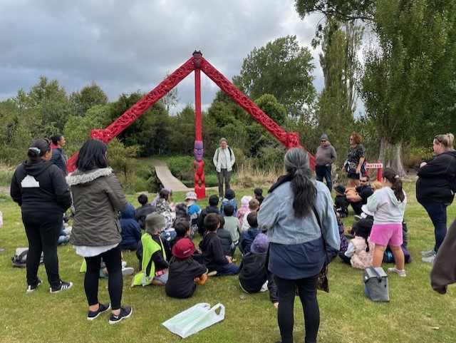**Mawai Hakona Trip:** We had a fabulous trip to Mawai Hakona/Silverstream Stream yesterday. It’s lovely to see how well the stream has been cleaned out and has so many native trees planted along it. Thank you to Whaea Kate from Fergusson Intermediate who spoke to the Tamariki about the area, and to Tipene Chrisp who was also supportive in the role of explaining the amazing carvings.

Thank you to all of you who attended the trip with us – our Tamariki seemed to really enjoy themselves.

I’ve lived in Upper Hutt for 23 years, and I’d never been to the area before! I will be visiting lots more from now as it’s a beautiful walk. We are so lucky in Upper Hutt to have such lovely places to visit.

**Easter Raffle:**

We are in the last few days for purchasing an Easter Raffle ticket. They are $2 each and available at the office. If you have any raffle ticket money at home, please bring it in and give to your teacher. There is loads of yummy things in this raffle – be in to win!

The raffle will be drawn at Assembly this Thursday at 2.30pm.

**Easter Holiday Break:**

I am sure the children are excited about the Easter break! I’m looking forward to getting a few things done around the house, preparing for the winter, and hunting for my Easter Eggs. Yum.

The Easter Holiday break is for 5 days including Friday 29th March through until and including Tuesday 2nd April. We’ll see you all back at school again on Wednesday 3rd April.



**Kaupapa mō te wiki/Value for the week:**

**Kotahitanga/Togetherness** – our mahi/work this week is to “help each other out”. We know how well tuakana-teina works (older children supporting younger children), and we like it when we are all helpful.

**Netball:** Whaea Donna will be in touch soon with teams, finding out who your coaches are, and with the netball draws for Saturday games. Be prepared for some afternoon practices coming your way.

**Heads up:**

* The **Bee Healthy Dental Bus** will here next week and the week after. Every child in the school will be seen by the Dental nurses.
* **School Start and Finish & Attendance:** Please remember that school begins at 9am and finishes at 3pm. It’s important children are at school ***every day and on time***. However, we would rather children were at school late than not at all. Getting to school by 9am is important for children’s routines. Thank you.
* **Absences:** If your child is not going to be at school, please advise the office via text on 0275269552, or via the Skool Loop app. Make sure you tell us the reason they are absent.
* **New Details:** If you have a new address or phone number, please let Roseanne know. It’s important that we have your latest contact details in the event of an emergency.
* **Potae/Sunhat:** Please ensure your child has a wide brimmed sunhat to wear during terms 1 & 4.
* **Entry in to and from School**: **Mornings -** drop your child off at the front gate or the back. Our carpark can be quite full and it’s safer to drop your child off at the gate and have them walk in. You do not need to drop them to the office unless they are running late – thank you.

**End of the day –**

* + Front gates are closed all day from 9am-3.10pm. We will cross children over at the end of the day. Please use the “crossing”.
  + Back gates: There will be two walking bus teachers to walk your children to the intersection of Hillside Drive, Moeraki, and Norana Roads and will be crossed over by the road patrollers.
* **Breakfast Club:** Runs 5 days per week from 8 – 9.30am. We require help on a Thursday & Friday. If you would like to volunteer for this job, please advise Roseanne or Rachel at the office. Thank you. Logo

  Description automatically generated
* **Lunches in Schools:** We provide lunches each day. The kai will be offered to every child. All children are expected to at least try the kai.
* **Water only:** We are a water only school which means children can only drink water while they are at school. We would encourage your child to bring a drink bottle of water each day.
* **Assemblies:** We hold our weekly celebration Assembly on Fridays at 9am. All whanau are welcome to attend.
* **School Values** – we teach the ākonga/students about these values every day. It would be great if you would be able to speak with your child at the end of each day to find out what they learnt about the values:
  + Whakaute/Respect
  + Akohia/Learning
  + Kotahitanga/Togetherness
  + Atawhai/Kindness
* **Covid protocols:**

The advice from Ministry of Health regarding Covid protocols is:

* If your child feels unwell, test for covid.
* If they test positive, they should stay at home and rest for 5 days from the first day they felt unwell.
* They are likely to continue to test positive for a while after that, but they can still return to school as long as they are feeling well.

If your child is unwell at all, we will send them home.

Ngā mihi nui

Karen Wellington,

Kaihautu/Timekeeper on the Waka

**Schedule of Events Term 1, 2024**

|  |  |
| --- | --- |
| Week 8 25-29 March | Traditional Māori Games – Seniors TMP  Good Friday – Easter Holiday |
| Week 9 1-5 April | Easter Monday and Tuesday – Easter Holidays |
| Week 10 8-12 April | Last day of term 1 12th April. Return to school on 29th April.  9th-12th April – Dental Van/Bee Healthy Bus at school.  First day back in term 2 is Monday 29th April 2024 at 9am. |

----------------------------------------------------------------------------------------------------------------------------------



*Upper Hutt City Council are currently conducting a Representation Review, this is an essential process required at least once every six years. The purpose of this review is to make sure that the communities in our city are both fairly and effectively represented. Any agreed changes will be put in place for the next council elections in 2025.*

*Representation Review focuses on evaluating our current governance structures and options for wards and community boards by looking at the following factors:*

·         *Help shape the future by sharing your thoughts on the following key factors:*

*The overall number of councillors in our community.*

·         *Details about wards, including their names, the number of councillors per ward, and their precise boundaries.*

·         *Community boards: does the community want them? If yes, the review must also consider how they’re setup, including names, locations, and the number of members.*

*Currently, the Upper Hutt community is represented by a mayor and ten councillors who are elected across the whole of Upper Hutt. There are no community boards. This review will examine our representation model, considering the appropriate number of councillors and the establishment and structuring of any additional wards and community boards. We’re conducting a questionnaire as the third phase of this review; Council has already made two important decisions. These are:*

*a.                   The inclusion of at least one Māori ward*

*b.                   The election will be conducted using ‘first past the post’*

*For the assessment to be fair and effective, they first need a good understanding of the communities that make up Upper Hutt.*

*For more information and to take the survey, please visit:*[*https://letskorero.upperhuttcity.com/rep-review-24*](https://urldefense.proofpoint.com/v2/url?u=https-3A__letskorero.upperhuttcity.com_rep-2Dreview-2D24&d=DwMFaQ&c=_Zm2Kb9yJrso4r0-N78Ezl-a6DfgMbIISn5tZXXqWk4&r=TeHXo6rNVHyd6f-2HcnkX2A70af38vtOdcaVnlV-Fm8&m=5T1D_KLGud7WsgFFKXRSsK7WdwCADaga4TvKAcRrnUqjvt8kfDpu6dkIOAZd_b6E&s=eUJWQoyxhOYuqHwy16DO80i0DqQC56z9q8_y8LPsy7Y&e=)