**Te Kura o Hau Karetu**

He waka eke noa: *We’re all in this waka together*

32 Hillside Drive, Māoribank, UPPER HUTT 5018

Phone (04) 5269-552, 027-5269-552

Email: office@tehaukaretu.school.nz

**23 July 2024**

Kia ora, Talofa Lava, Mālō e lelei, Kia orana, Namaste, Kumusta,

It’s great to be back to normality and into the swing of things for term 3. School holidays are a time for refreshment, and I know many of you will have created some amazing memories with your whanau/families – time that is precious. We are also aware that many people had a challenging time over the break with bereavements and illness. As well, in the middle of winter with a lack of sunshine, life can feel tough at times. If you are in need of some fun and laughter, we encourage you to come down to school and help out any time – our Tamariki have that effect – always make you smile. 😊



**Kaupapa mō te wiki/Value for the week:**

Our value for this week is all of them – Whakaute/Respect, Akohia/Learning, Kotahitanga/Togetherness, Atawhai/Kindness. Generally in all terms the first and last weeks are learning about all values. We would love it if you would ask your child about the school values and what kinds of things they have to do at school to show them each day.

**Property news:** - The roof on our school pool is nearly completed. It has really smartened up the building. Thank you to TW Clark Ltd who have completed the job. It has provided so much more light in the building and as well, we have a bit more ventilation in the building which means we’ll have slightly less “rain” on us when we’re teaching swimming!

Very soon, we will be having some work done on our drains at school. This will likely create a few issues around space in the playground, but we’ll be in contact with you when this happens.

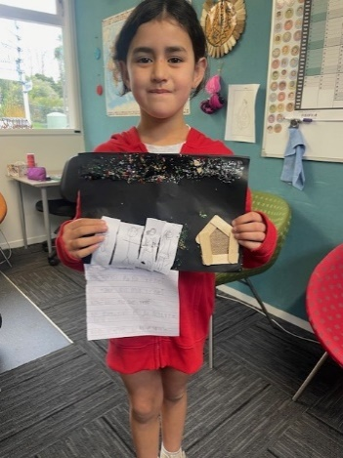**Golden Child:** Millie came to see me this morning with an amazing story she’d written with some beautiful artwork. The story says: Ko tōku whānau tēnei. Ko tōku pāpā tenei. Ko tōku māmā tenei. Ko Matariki ki runga i te rangi. Ko Millie tēnei. Ko Kiwa tēnei. This is my family. This is my father, this is my mother. Matariki stars are up in the sky. This is me, and this is Kiwa. Mīharo, Millie!

**Principal’s Awards:** It was awesome to see how many people won the Principal’s awards on the last day of term – it seemed as though there was about a quarter of the school! Children win these awards for a variety of reasons including for showing school values, and doing some marvellous learning. We are so proud of you all.

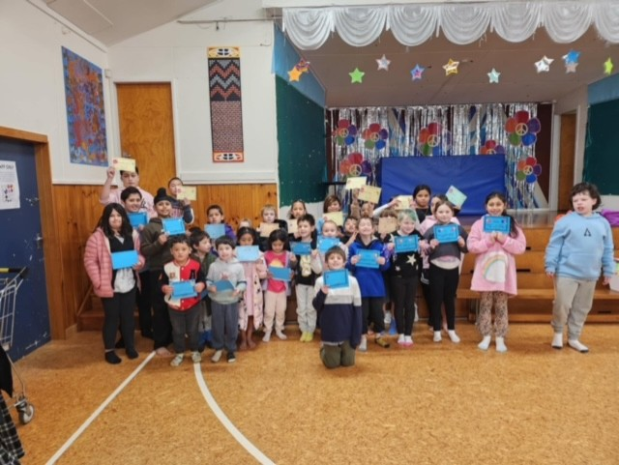

**Heads up:**

* **School Start and Finish & Attendance:** Please remember that school begins at 9am and finishes at 3pm. It’s important children are at school ***every day and on time***. However, we would rather children were at school late than not at all. Getting to school by 9am is important for children’s routines. Thank you.
* **Absences:** If your child is not going to be at school, please advise the office via text on 0275269552, or via the Skool Loop app. Make sure you tell us the reason they are absent.
* **Entry in to and from School**: **Mornings -** drop your child off at the front gate or the back. Our carpark can be quite full and it’s safer to drop your child off at the gate and have them walk in. You do not need to drop them to the office unless they are running late – thank you.

**End of the day –**

* + Front gates are closed all day from 9.30am-3.10pm. We will cross children over at the end of the day. Please use the “crossing”.
  + Back gates: These are locked during the day and will be opened again at 3pm. There will be two walking bus teachers to walk your children to the intersection of Hillside Drive, Moeraki, and Norana Roads and will be crossed over by the road patrollers.
* **Breakfast Club:** Runs 5 days per week from 8 – 9.30am. We are always in need of volunteers for Breakfast Club please. If you would like to volunteer for this job, please advise Roseanne or Rachel at the office. Thank you. Logo

  Description automatically generated
* **Lunches in Schools:** We provide lunches each day. The kai will be offered to every child. All children are expected to at least try the kai.
* **Water only:** We are a water only school which means children can only drink water while they are at school. We would encourage your child to bring a drink bottle of water each day.
* **Assemblies:** We hold our weekly celebration Assembly on Fridays at 9am. All whanau are welcome to attend.
* **School Policies:** Our school policies and procedures can be found at schooldocs.co.nz, username: maoribank and password waka. We would encourage you to check these out as we will ask you to have your say on their review every three years. Our current policies for review are:
  + Concerns and Complaints
  + Media
  + Performance Management
  + Protected Disclosure
  + Professional Development
  + Staff Conduct
  + Staff Leave

Ngā mihi nui

Karen Wellington,

Kaihautu/Timekeeper on the Waka

**Schedule of Events Term 3, 2024**

|  |  |
| --- | --- |
| Week 1  22-26 July | Monday – Mihi Whakatau for new students and their families  Friday – the Olympics begin! |
| Week 2  29 July-2nd Aug | Te Mataahae whānau – please see the letter from Wainuiomata High below… |
| Week 3  5-9 Aug |  |
| Week 4  12-16 Aug | Tuesday - Basketball at Walter Nash Stadium – Senior students only |
| Week 5  19-23 Aug |  |
| Week 6  26-30 Aug | Thursday – Hui for Families of Children who are Neurodiverse – 5pm. Focus on speech language, and a letter to the government. |
| Week 7  2-6 Sept | Tuesday - Rippa Rugby at TMP – Matua Shea will send details soon. Thursday is postponement day. |
| Week 8  9-13 Sept | Friday – Wig and Onesie Day. Fundraising for Child Cancer and Wellington Free Ambulance. Wear a Onesie or wear a wig/crazy hairdo. Please bring a donation. |
| Week 9  16-20 Sept | Te Wiki o te Reo Māori – Māori Language Week. Watch this space, as you can be sure we’ll be doing something amazing throughout this week. |
| Week 10  23-27 Sept | Sausage Dog by DewlightAdopts on DeviantArtBook Week and Book Character Day on Friday.  Structured Literacy Information Evening for parents Monday 5.30pm.  Mrs Wellington gets her new puppy this week! |

_____________________________________________________________________________________________________

Kia ora from Waiunuiomata High,

Ngā mihi nui ki a tātou e pae nei. Tērā a Matariki e ārau ana i te rangi hei tohu i te tīmatanga o te tau hou Māori. E tohu ana ki a tātou kia hauhake i te kai, kua maoka te hinu, ko te mātahi o te tau. Tēnā koutou katoa.

I'm contacting you to let you know of the upcoming Wharekura events early Term 3 and would like your kura to be part of the following:

* Wharekura Tour = July 30th & July 31st
* Y8 Open Day = August 5th
* Y8 Open Evening = August 7th

The hope is that we can showcase, perform, sing, talk to students, staff and whānau about the Wharekura and possible enrolment into the Wharekura next year and/or the near future. We had a ball last year on tour and hosting whānau for our Open day and evening and hope to do the same thing again this year.

**Wharekura Tour, Open Day & Open Evening**

Booking link for the Wharekura on Tour and Expression of Interests form for the Open Day, and Open Evening

[https://forms.office.com/r/6M6LhEdSYM](https://urldefense.proofpoint.com/v2/url?u=https-3A__forms.office.com_r_6M6LhEdSYM&d=DwMFBg&c=_Zm2Kb9yJrso4r0-N78Ezl-a6DfgMbIISn5tZXXqWk4&r=TeHXo6rNVHyd6f-2HcnkX2A70af38vtOdcaVnlV-Fm8&m=bhg8l4HotIASn2OKxmpPU6y5czzxSur1QP1ULfbXwuFf98nwkz90vu1x2rlgsmJH&s=T0ULQ8rdFDTG7fi2ddUdEfElI6x2m0xYJVY_wet2_q8&e=)

Now... although there are highlighted options in the form and we'd like to ensure you get you best time and day. Please make note if multiple schools choose the same day and same time we will make contact to see if schools are flexible to change so that it still works out for all parties, nō reira kia manawanui mai e kare mā.

Heoi, i runga i ngā whakaaro nui o te wā tēnei a whakamānawa ki a koutou ahakoa e ngaua kino nei tātou e te kōpeke, e te anu mātao, e Hine Takurua.

If you have questions please get back to me as I plan to have the program sorted during the school holidays or at the latest in Week 1, Term 3.

We look forward in hearing back from you soon.

Ngā manaakitanga,

Mātauranga Te Rauna

Pou Ārahi Reo Māori

Pou Upoko Wharekura

Tumuaki Tuarua / Deputy Principal

Te Kura Matua o Wainuiomata

Wainuiomata High School