

1 April 2025

Kia ora, Talofa Lava, Mālō e lelei, Kia orana, Namaste, Kumusta,

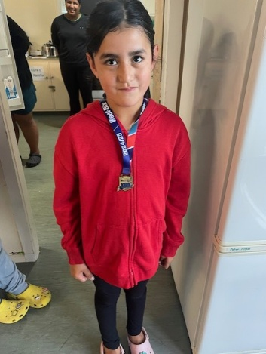

Happy April Fool’s Day – the trick is, the newsletter was supposed to be out on the 1st of April – and it’s been sent out on the 2nd of April instead! 😊

**Wow Millie!** She ran in the Weetbix Tryathlon on the 16th March. She proudly showed me her medal – and she should be proud – doing a Tryathlon is incredible! Tino pai Millie.

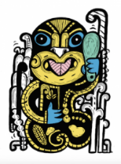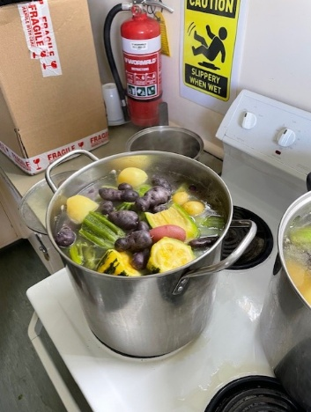**Garden to table 10 years** – Te Kura o Hau Karetu has been in Garden to Table for 10 years – that’s an amazing feat. We haven’t always done the “Table” part, but we regularly do the gardening. Thanks to Nicola who works hard behind the scenes to keep our gardens nice. Te Mataahae also have their own gardens, and recently had a yummy boil up with all the vegetables they grew in their gardens. There are taewa and rīwai/Māori potatoes (really good for you – they have all the purple vitamins), varieties of marrows – they had all the colours of the 5+a Day included in the boil up. Thank you Whaea Dani for doing the cooking!

**Kaupapa mō te wīkī:** Our Kaupapa/value this week is Atawhai/Kindness – We are getting caught using our manners. That means we not only say “please” and “thank you”, but we also take turns and share when we are using manners. Sometimes, opening the door and letting your teacher through the doorway first is a way of using good manners.

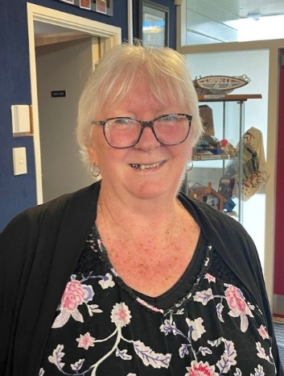

**Whaea Kim and Whaea Gipsy – Haere ra:**

Next Thursday 10th April at 11am, we are holding a mihi whakawātea/farewell celebration for Whaea Kim and Whaea Gipsy in the hall. All are welcome to attend.

Whaea Kim has been working as a teacher aide here at our school for about 30 years, and prior to that, was a parent help when her own children attended Māoribank School way back. Kim has taught and supported so many children over the years in a professional, friendly way. We are going to miss her so much, but happy for her that she’s going to take time in retirement to do some things for herself now.

Whaea Gipsy is our Social Worker in Schools (SWIS). She has now left as a SWIS and is going to do some other amazing things – do you know she is currently doing her PHD!? That is going to keep anyone busy.

We want to thank both Kim and Gipsy for the mahi they have done with us, the kindness they have shown us all, and wish them both well for their next adventures.

**Mihi Whakatau/welcome:** We are holding a mihi whakatau which is a special welcome to all our newbies including new students and their families and staff. This will be held on the first day back at school for term 2, Monday 28th April at 9:15am.

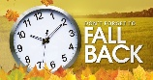**Daylight Saving ends this weekend** – put your clocks back 1 hour on Sunday morning at 2am. Did you know that only a third of countries in the world practice daylight saving?

**Introducing…..**

We are so lucky - we have two new navigators on our team with I Have a Dream. Nau mai, haere mai to Whaea Numa and Matua Henry. Whaea Numa will be working with our year 1 students, Matua Henry with the years 2-3 students, and Whaea Maima will continue working with our year 4-5 cohort. Anyone who wants to sign their child up with I Have a Dream, come to see the Navigators after school in the old library.

When your child works with the Navigators, they will get to do some special activities after school (plans to be advised), will have access to transport to school (needs to be okayed by Karen first), activities during lunch times, supporting families and whānau where needed, and work with children in the classroom to get to know their strengths and needs. The plan is that anyone who signs up to IHAD will also have them work through to intermediate and college to support their journey so they have someone familiar to encourage them along their learning journey right into tertiary education or employment.

We will be holding an IHAD event soon, but in the meantime, come and meet the team in your child’s class or after school.

**Numa -** Kia ora koutou, I am excited to be joining Te Kura o Hau Karetu as a Navigator for the I Have A Dream programme. I will be working with our new entrants and Year 1 cohort and look forward to getting to know and support them and their whānau, throughout the year. My contact details are email: Numa@4abettercity.nz and phone: 021 245 1268

**Henry** - My name is Henry, and I am part of the I have a dream (IHAD) navigation team based in Te Kura o Hau Karetu. My experience is working as a navigator and respite peer. My professional background is with adults and adolescents in the mental health and disability sector. I have made the switch to work with our younger people within the Kura. I joined this team to see our young people of the Kura grow and maximize their full potential. I will be journeying alongside the year 2 and 3 cohort. I look forward to meeting and getting to know as many of you as possible.

Kia Ora e te Whanau! **Whaea Maima** here loving the mahi. Nga mihi nui for letting me navigate kura with the tamariki. So proud of our Dreamers in years 4 to 5. Nurturing future leaders, superstars love it Cheehuu!!

**Heads up:**

* **Nits:**

They have begun to rear their ugly heads. It’s important that you treat your child’s nits as soon as you notice them. Advice on nit prevention:

* + Please tie your child’s hair up if it is long.
  + Don’t share brushes or combs – each child should have their own.
  + We don’t allow children to share hats/potae.
  + Treatments can be sourced from school, or through your doctor/medical centre on prescription
  + Regularly check your child’s head for nits.
  + Combing through conditioner using a nit comb is a great way of keeping them away.
  + If you find nits on your child, you should check all family members.
  + Head lice only survive on humans. They die quickly when they are not on the head, usually within 24 hours.
  + We’re all in this together – everyone please treat their kid’s heads and we’ll get out of the cycle.
  + For further information go to: <https://www.kidshealth.org.nz/head-lice>
* **Covid** – covid is still around. If you or your child have the following symptoms, it’s best to test for Covid just in case, as it can have some nasty long-term effects. We do not have any covid tests left at school. You will need to go to your pharmacy if you want covid tests.
* **Attendance:** We are back up to 87.1% attendance this week – woo hoo! Thank you everyone. I know it’s tough getting tired children up out of bed every morning, but we really appreciate it. We absolutely must get our kids to school so that we have the best outcomes for them in their lifetime. Sending them to school every day helps to set up great habits for life. One thing I was reading about today was how learning positively impacts a person by fostering personal growth, enhancing skills and knowledge, boosting self-confidence, and improving mental well-being, which all lead to a fulfilling and successful life. Ultimately, that’s what we all want for our tamariki.

Ngā mihi nui

Karen Wellington

Tumuaki/Principal

**Events Term T1 & 2 2025**

|  |  |
| --- | --- |
| Week 10 7-11 Apr | Kim and Gipsy’s mihi whakawātea/farewell Thursday 10th April 11am – all welcome  Last day of school 11th April at 3pm |
| Week 1 Term 2 | Return to School Monday 28th April. Mihi whakatau/welcome for newbies and their whānau, including our 2 new navigators. Ladies, please wear a dress or a skirt. Thank you. |
| Friday 30th May | Teacher Only Day – please do not come to school on this day – it will be a lovely long weekend for you as it’s also King’s Birthday weekend on Monday 1st June. |

**School Holidays:**

The RNZB is pleased to offer kura students and their whānau $10 tickets to our upcoming performances of Dazzlehands: The Ballet. Performed in Upper Hutt at Whirinaki Whare Taonga on the 23rd April, **with full narration in Te Reo Māori at 2:30pm.**

Use the code “SCHOOL25” when booking. Get tickets at <https://rnzb.org.nz/show/dazzlehands>