

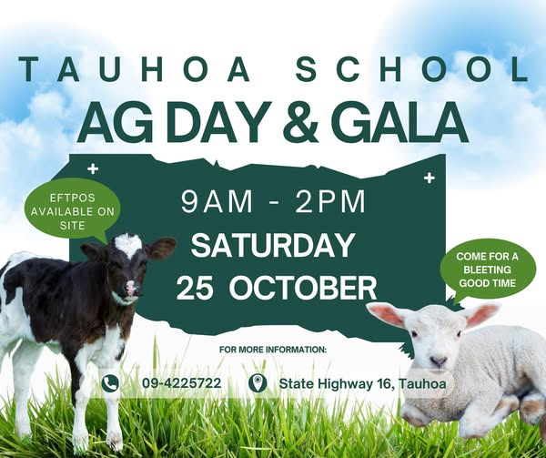

**Ag Day and Gala Special**

**October 20th 2025**

***Only 5 days to Go!!!!***

We are counting down to our biggest day of the Year for our school and community, our Ag Day and Gala!!

It's all hands on deck, and everyone is now joining together to make this day successful for our community and the school!

This newsletter will help those of you who are new to our school with details and information. Please, if you have a question, ask!!!

**Bucket Raffles**

By now, you should have filled your bucket and be bringing it back in the next day or two. We can store cold items and frozen meat, etc, so don’t let that stop you from returning them early.

You should be making sure all your bucket raffle tickets are sold and returning the money to the office. Tell people they are on sale on the day.

**Roster**

The final copy of the roster is coming home today. If you have not popped your name down on a particular spot, the team will allocate you some time to help.

Please sign the attached form and return it so we know you know what time and where you're on. Remember, we all need to do something towards this day.

**Animals**

All animals should be registered by now. All animals must be here by 9 am and registered at the desk by the ring on the lower field.

Pets do not need to register and come up outside the Principal's office on the sports box!

A reminder to move chickens under the trees after judging. All animals must be looked after during the day and have water available to them.

**White Elephant**

We still need saleable items for the white elephant. Please drop off at school this week. Remember, they would be things you would see at an op shop! No clothes this year.

**Baking**

We still require people to supply baking for the cafe. Please drop this off on Friday or Saturday morning.

**Plants and produce**

We may also need donations for the produce stall, extra jam loaves, or veggies. Please drop them down. Any extra seedlings you might have will also be welcomed on the plant stall.

**Potatoes**

The judging day has had to change due to the Strike day on Thursday. Please bring your potato entries to be weighed and judged on Wednesday this week. Do not remove the soil! If they are, they will not be entered into the competition.

**Competitions**

Cakes

Consider your family and others entering our cake competition. There are men's, women's, and youth sections with great prizes. Please drop off either Friday or Saturday morning at the staffroom.

Fudge

Make a batch of your secret recipe and bring eight pieces to be judged**.**

Jams and Preserves

Again, raid your larder and enter that fabulous jam to win this section.

**All entries for these competitions need to be at school by 9 am, ready for judging.**

**Events**

We have some fantastic things happening on the day.

Hard Rock Motors wheel change, pony rides, popular student-created games, plus a coconut shy and horizontal bungee. Plus some great music, raffles, plant stall, silent auction and our world-famous bucket raffle! Enjoy some great food off our BBQ, including mussel fritters and a lovely cafe with home-cooked treats.

**School Hats**

These need to be back on everyone's heads this term. Some have been handed into the office if they didn't go home for a wash.

**School Lunches**

**We still need a roster of whanau volunteers to come and heat our meal on a Friday and clean up after lunch. Please let the office know if you can do a Friday for us.**

**WHAT'S ON?**

**October**

* **23rd Strike Day School will be closed**
* **24th In-Class activities and craft day for Ag Day.**
* **25th Ag Day and Gala**
* **27th Labour Day School closed**
* **29th School Board Meeting**

**November**

* **1st Halloween Disco Tauhoa Community Hall 6 pm-8 pm**
* **21st RRS Athletics Day Whole school**
* **28th Teacher Only Day SCHOOL CLOSED**

**December**

* **5th Community Celebration Night BBQ, etc.**
* **9th Year 8 Graduation Dinner**
* **10th Helpers, thank you morning tea**
* **11th End of year assembly and Prizegiving 6-30pm**
* **12th School closes for 2025 at 12-30pm**

**January 2026**

* **28th Office open for enrollment and stationery**
* **29th First day of school**

**Febuary**

* **6th Waitangi Day**
* **13th School Beach day**
* **16th - 20th Camp week**

**Term Reminders: Term 4 only**

* **School hats must be worn at all times.**
* **We are a healthy lunch school. If you choose to send a lunch to school, please supply a healthy lunchbox** [**https://nutritionfoundation.org.nz/lunchbox-ideas/**](https://nutritionfoundation.org.nz/lunchbox-ideas/)
* **We keep personal stationery at home and use school supplies only at school.**

**Strike day**

**We are closing on Thursday, 23rd October, due to the strike day, as we do not have staffing to keep the school open.**

**We are *open* on Friday, and students will be getting their in-class activities completed..**

**Halloween Disco**

The FOTS team will run their annual Halloween Disco on Saturday, 1st November, at the Tauhoa Hall from 6 pm to 8 pm. $5.00 entry fee, please bring a plate to share and some money for dinks and disco items to purchase. Can’t wait to see everyone's spooky costumes!

**Teacher Only Day 28th November**

MOE allocated two teacher-only days that did not need to be made up this year. This is our second one in the new curriculum.

**Student parent orders or provisions**

If you have any orders or provisions regarding people who can’t access or collect your child from school, please contact the office urgently so that this information can be logged in our secure information portal.

**2026 Enrolments**

We have a few spaces available for 2026. If you know someone interested, please encourage them to contact the school this week. Likewise, if you plan to leave, please let me know so we can offer your place to someone who wants to attend Tauhoa School.

**Menu Week 3 Menu Week 4**

**Monday** - Cheeseburgers **Monday** - Labour Day

**Tuesday** - Butter Chicken **Tuesday** - Beef Ginger Bowl

**Wednesday** - Chicken Pasta Salad **Wednesday** - Bento Bowl

**Thursday** - STRIKE DAY **Thursday** - Nachos

**Friday** - Soup **Friday** - Hawaiian Pasta Salad

Tae noa ki muri.

Vivienne Goldsmith

Principal

| **Staff and Board Contact Details 2025**  *Principal*  Vivienne Goldsmith; [principal@tauhoa.school.nz](mailto:principal@tauhoa.school.nz)  *Deputy Principal and Teacher Hoteo Room:*  Ms Annette Bryant; A[nnetteb@tauhoa.school.nz](mailto:annetteb@tauhoa.school.nz)  Teacher Atiu Room,  Miss Cinnamon Davies; [Cinnamon@tauhoa.school.nz](mailto:Cinnamon@tauhoa.school.nz)  Teacher Cleasby Room  Mrs Rebecca Kelly Rebecca@tauhoa.school.nz  Teacher Te Pahi Room  Mr Richard Goldsmith; [Richard@tauhoa.school.nz](mailto:Richard@tauhoa.school.nz)  Learning Support Worker Hoteo)/ School cleaner  Alice Cunningham; [office@tauhoa.school.nz](mailto:office@tauhoa.school.nz)  Learning Support Worker (Atiu)  Robyn Froggatt; [office@tauhoa.school.nz](mailto:office@tauhoa.school.nz)  Learning Support Worker / Student Teacher  Lashae Mcardle; [office@tauhoa.school.nz](mailto:office@tauhoa.school.nz)  Office Manager  Ms Jody Otway; [office@tauhoa.school.nz](mailto:office@tauhoa.school.nz)  Property Manager:  Allan Duffin [office@tauhoa.school.nz](mailto:office@tauhoa.school.nz)  Presiding Member, School Board:  Debbie Mason [Debz_paul05@hotmail.com](mailto:Debz_paul05@hotmail.com)  FOTS Chair  Bridget Boler [boler@outlook.co.nz](mailto:boler@outlook.co.nz) |
| --- |