
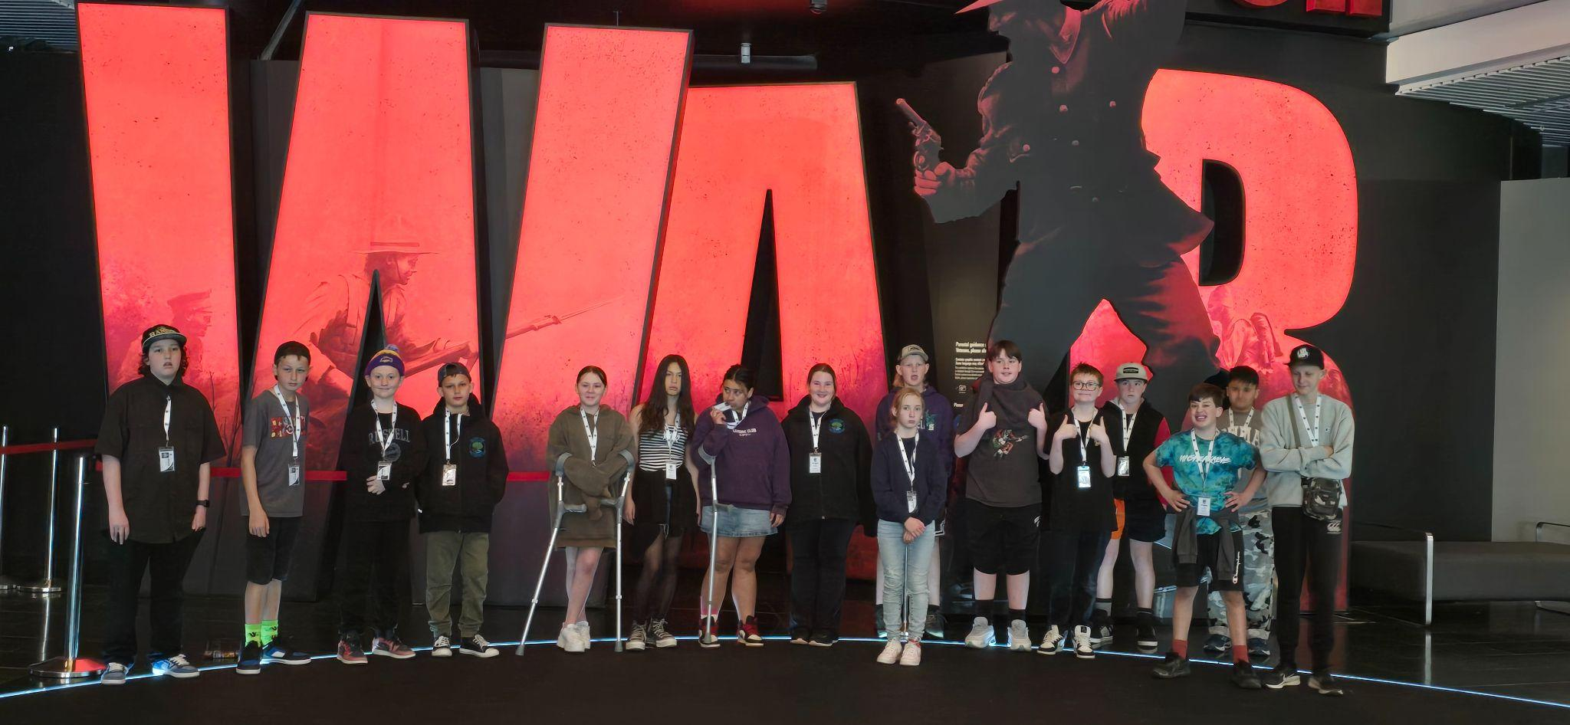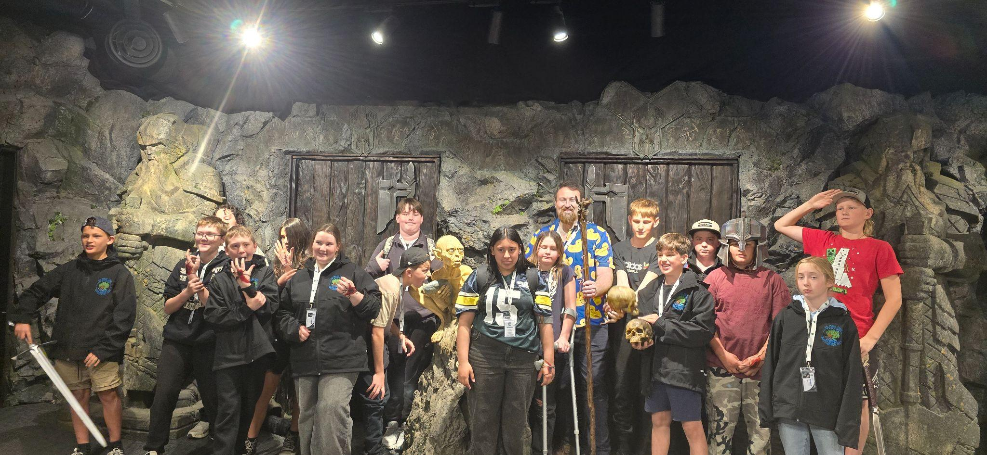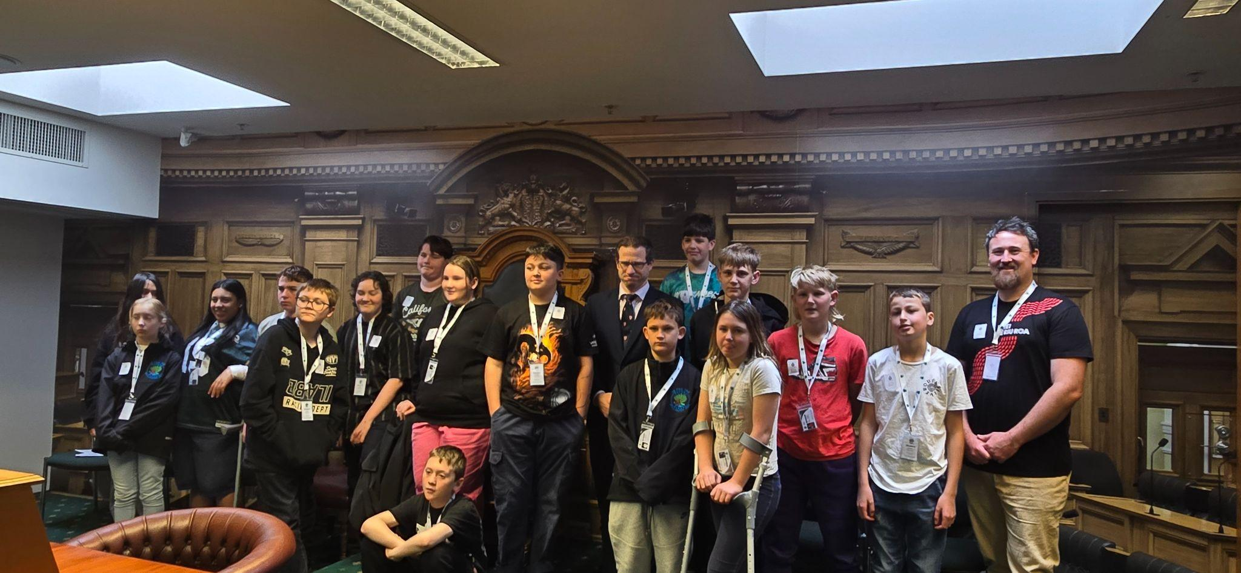
TAUHOA TATTLER #16
October 8th 2025

Tena koutou ki aku hoa,
The last weeks of term 3 were quite fast-paced and full of amazing experiences for our year 7 and 8 students.
I know there are many people to thank for the energies and efforts that made this trip possible, but Deb Mason had planned, organised, and motivated us to ensure this trip went ahead. Thank you, Deb. Thank you to the many parents who made time to fundraise and support the students on this trip.

Cross Country
Thank you to all those who helped at the Cross Country. This too was a wonderful day.


These photos showcase some outstanding students doing their Tauhoa BEST, supporting one another.

I had attended some amazing PD in Wellington at the NZPF conference, for which I had won an award to attend.
Not only did I contract the flu, but I also had the opportunity to hear some fantastic speakers and attend some excellent workshops.

AI and its place in our schools and students' futures was a key message from some speakers.
Others were about the behaviours we accept in school and at home. Best-selling author Barbara Coloroso spoke about Brick Wall, Backbone, and Jellyfish parenting and student management. Here's a breakdown of each style:
- Brick Wall Parenting:
  - Description: This style is authoritarian. The parent is rigid, unyielding, and demands blind obedience, much like a brick wall. Rules are strictly enforced, often through threats and bribes, and there is little room for negotiation or dialogue.
  - Characteristics: High control, low warmth, "My way or the highway."
  - Potential Outcome for Children: Children may be compliant but may lack self-esteem, independence, and the ability to think critically or make informed decisions.
- Jellyfish Parenting:
  - Description: This style is permissive. The parent is overly flexible, inconsistent, and sets few clear rules or boundaries, like a spineless jellyfish floating on the current. The main goal is often to keep the child happy, avoiding confrontation.
  - Characteristics: High warmth, low control, inconsistent expectations.
  - Potential Outcome for Children: Children may struggle with self-control, social responsibility, and insecurity due to a lack of structure and boundaries. They may become "little emperors."
- Backbone Parenting:
  - Description: This style is authoritative. It is seen as a healthy balance between the two extremes. The parent is supportive and loving (high warmth) while also setting clear, consistent, and reasonable boundaries (high control), like a flexible but firm backbone. It involves mutual respect, dialogue, and teaching children to think critically and independently.
  - Characteristics: High warmth, high control, clear rules, open communication, and teaching discipline.
  - Potential Outcome for Children: Research suggests this style tends to raise the most well-adjusted children who exhibit high self-confidence, independence, and social responsibility.
Another speaker who ran an online workshop is Principal Jared Lamb, a well-known figure on Facebook. Often talking about the hills you die on, his workshop resonated with me, and I fully intend to follow some of his ideas. As he suggests, I will ensure that all my students have the opportunity to learn.
To that end:
Teachers need to teach. If a student doesn't want to be part of the learning and disrupts it for others, they will be removed from the class, and I'll ring to let you know that has happened. They will be asked to complete schoolwork with me. Any disrespectful behaviour will be treated the same way. No student has the right to disrupt the learning of others.

School Hats
These need to be back on everyone's heads this term. Some have been handed into the office if they didn't go home for a wash.

School Lunches
School lunches will be provided 5 days a week, funded at $4 per student this term. (Remembering this has to cover our chef, food, and other costs, it doesn't go far.) Jo has agreed to drop her hours to help maintain the programme; however, we need a roster of whanau volunteers to come and heat our meal on a Friday and clean up after lunch. Please let the office know if you can do a Friday for us.

WHAT'S ON?

October
- 6th Start of term 4 (12th December, Last day of school year)
- 8th Applications close for out-of-zone placements
- 10th FOTS meeting 2-30pm
- 15th Ballot Day if required
- 23rd Strike Day School will be closed
- 24th In-Class activities and craft day for Ag Day.
- 25th Ag Day and Gala
- 27th Labour Day School closed
- 29th School Board Meeting
November
- 21st RRS Athletics Day Whole school
- 28th Teacher Only Day SCHOOL CLOSED
December
- 5th Community Celebration Night BBQ, etc.
- 9th Year 8 Graduation Dinner
- 10th Helpers, thank you morning tea
- 11th End of year assembly and Prizegiving 6-30pm
- 12th School closes for 2025 at 12-30pm
January 2026
- 28th Office open for enrollment and stationery
- 29th First day of school
Febuary
- 6th Waitangi Day
- 13th School Beach day
- 16th - 20th Camp week
Term Reminders: Term 4 only
- School hats must be worn at all times.
- We are a healthy lunch school. If you choose to send a lunch to school, please supply a healthy lunchbox https://nutritionfoundation.org.nz/lunchbox-ideas/
- We keep personal stationery at home and use school supplies only at school.

FOTS Meeting
On Friday, we are having a get-together to discuss our Ag Day. Please join us to find out how the Ag Day organisation is going. 2:30 pm in Atunui Room

Tins and things.
We urgently need clean, de-labelled tins at school. These are so we have enough for all students to repurpose tins as part of our in-class Ag Day activities.
In the past, Families had to provide everything for these costly activities. We have made this change to help families, but we need your support to make it happen.

Teacher Only Day 28th November
MOE allocated two teacher-only days that did not need to be made up this year. This is our second on the new curriculum.

Student parent orders or provisions
If you have any orders or provisions regarding people who can’t access or collect your child from school, please contact the office urgently so that this information can be logged in our secure information portal.

Bucket Raffle
Hopefully, you have come up with a fun idea for your bucket and have started selling your tickets. Instructions came home on how to fill the bucket. Please send your bucket back to school filled with goodies, generally themed in some way and keep selling as many bucket raffle tickets as possible.

Theft
Sadly, we had someone trying to steal our gas bottle. The school is well-protected by security cameras, and we now have your car on file
Please remember this when coming to school at any time: night or day. My phone alerts me to people at school.
When you steal from a school, you actually take from the students.

Ag Day and Gala October 2025
Animals
Please let us know if there have been any changes regarding the animals you have registered. It is not too late to register any who have ’turned up’ now.
White Elephant
We are collecting for this now. Please feel free to drop off boxes of saleable items at your convenience. Thank you to Libby Clews for taking this part of the Day under her belt.
Competitions
Have you thought about entering some of our great competitions on the day? Check out the Ag Day booklet for more information.
Sponsors
We desperately need sponsors for prizes and our silent auction. Start asking around for these.
Helpers Form and Roster
This will be updated and come home today. This is the last opportunity to provide feedback on where and when you would like to schedule your two slots. After this, the organisation team will allocate a spot to each family to help on the day.
We still need people to lead areas.

Caretaker
We are seeking a permanent Caretaker starting this term. The ideal candidate should have handyman skills and the ability to think quickly. This role involves 10 hours per week. Please contact the office for application forms and a job description.

2026 Enrolments
We have a few spaces available for 2026. If you know someone interested, please encourage them to contact the school this week. Likewise, if you plan to leave, please let me know so we can offer your place to someone who wants to attend Tauhoa School.

School Camp
Our school camp week runs from February 16th to 20th, 2026. This camp is held at school, where we participate in various activities in mixed groups. We also organise a couple of after-hours activities for our senior students. So far, we have surfing booked for years 7 & 8, Woodhill Ropes trip for years 6 to 8, and mountain bikes and a rock climbing wall arriving at school. Years 0 to 4 will be out all day on Thursday, heading to a special destination.

The classes, depending on year level, will be camping out at school. Year 7 and 8 students spend the most time camping out at Naumai Reserve, while years 0-2 sleep over for one night.

Under our new Parent Involvement procedures, we have introduced a new approach for those wishing to help out.
If you wish to participate this week, a notice will be sent out later regarding parent support. However, if you're thinking of sleeping at school with your child, you must be police vetted to do so. Please consider getting police vetted this term.

Tae noa ki muri.

Vivienne Goldsmith
Principal

Staff and Board Contact Details 2025
Principal
Vivienne Goldsmith; principal@tauhoa.school.nz
Deputy Principal and Teacher Hoteo Room:
Ms Annette Bryant; Annetteb@tauhoa.school.nz
Teacher Atiu Room,
Miss Cinnamon Davies; Cinnamon@tauhoa.school.nz
Teacher Cleasby Room
Mrs Rebecca Kelly Rebecca@tauhoa.school.nz
Teacher Te Pahi Room
Mr Richard Goldsmith; Richard@tauhoa.school.nz
Learning Support Worker Hoteo)/ School cleaner
Alice Cunningham; office@tauhoa.school.nz
Learning Support Worker (Atiu)
Robyn Froggatt; office@tauhoa.school.nz
Learning Support Worker / Student Teacher
Lashae Mcardle; office@tauhoa.school.nz
Office Manager
Ms Jody Otway; office@tauhoa.school.nz
Property Manager:
Bode Klein office@tauhoa.school.nz
Presiding Member, School Board:
Debbie Mason Debz_paul05@hotmail.com
FOTS Chair
Bridget Boler boler@outlook.co.nz

