**15th October 2025**

***Chicken Pox***

**As you are aware there has been a case of Chicken Pox in the school. We are very lucky here at Big Rock, when it comes to dealing with illnesses, particularly our families act very sensibly and selflessly.**

**I have attached a link with information regarding Chicken Pox. All we ask is that if your child has the symptoms or actual Chicken Pox, please keep them home.**

[Chickenpox | Healthify](https://healthify.nz/health-a-z/c/chickenpox)

***Good Luck***

**On behalf of us all I would like to wish Kade Hancock all the best as he heads off to Australia to compete in a tournament with teams from all over Australia and beyond.**

**Earlier in the year (January) Kade was selected to take part in a nation-wide football academy held in Hamilton at St Peter’s Collegiate. The academy players were selected by former professional footballer and former All Whites coach Ricky Herbert. Ricky took the All Whites to the 2010 World Cup, where they were unbeaten, drawing with the mighty Italians. Ricky knows his football. Since that summer academy, Ricky has selected 15 players from across the country to compete in the upcoming tournament in Melbourne. For all intents and purposes this a New Zealand selection team, Ricky Herbert would only choose the best, if the Ricky Herbert name is attached to it. Well done to our very own Kade Hancock on being selected as one of the 15 chosen, an incredible achievement and richly deserved.**

**Go well Kade, we are immensely proud!**

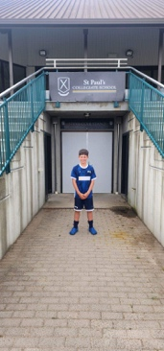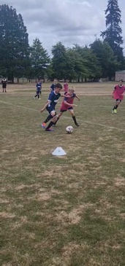

***Homework Heroes***

**This term we are trialling a new homework programme. Firstly, we understand that homework can be a real challenge at home, with busy schedules, tired children (tired parents), sport, music, drama, swimming lessons, surf club, bmx, pony club and a myriad of other out of school activities. The programme is not compulsory. Again, we understand that homework can cause disagreements and can be more challenging than it is worth. In recognising that, most of the homework can be completed by your child independently. In most cases, particularly from Year 4 down, it is about reinforcing what the children already know and how to do it.**

**It is important that this is also about developing independence and personal responsibility. It is the child’s job to bring it into school, not mum, dad or anyone else.**

**It will not be arduously long- unless the children decide to do more themselves which is great. Especially the research based homework.**

**In short, the children who complete the homework will gain a raffle ticket. Every Friday for the next 6 weeks we will have a lucky draw and the children whose raffle tickets are drawn out they will win a prize. Tickets that are not pulled out will stay in for next week’s draw. I have attached more information at the end of the newsletter. The children seem very excited about it, which is obviously a great start.**



***Congratulations***

**Congratulations to the following players who earned Player of the Day for their respective teams.**

**Big Rock Dolphins — Rhys Shayler**

**Big Rock Orca -- Ivar Elliot-Tressler**

**Big Rock Stingray -- Dion Mooyman**

**Big Rock Sharks -- Leo Garth**

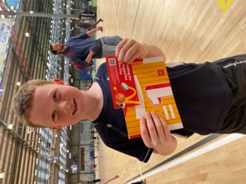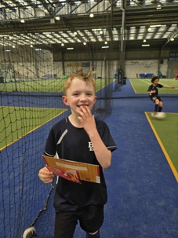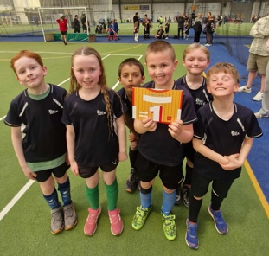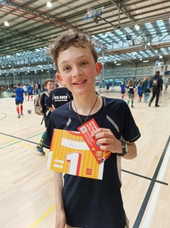

***A Wee Shout Out***

**Yesterday at morning tea it was incredibly windy. One of the children had a used wrapper from her lunch blow away. It would have been easy for her to just let it fly. No-one would have known, and if they had, in a weird way may have even understood. However, she gave chase and ran it down and secured it safely back in her lunch box. People talk about character and values. Your true character is not how you behave when people are watching, it is how you behave when no-one is watching.**

**Outstanding Ivy Nicolaou!**

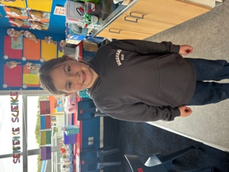

***Ukelele Jam***

**On Wednesday, a small but enthusiastic group of children, along with their student teacher, Miss Wells took part in a Ukelele Jam at Taieri College. They also won a piece of art put together by the staff at the Dunedin Art Gallery and represented all the children involved.**

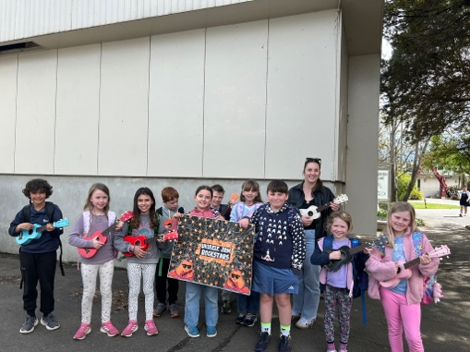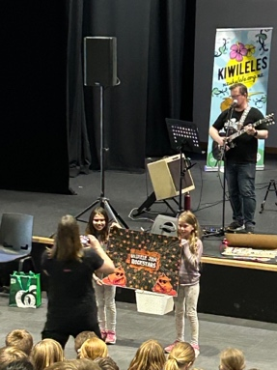

***Brighton Trail Ride***

**Earlier this year there was a school fundraiser that ensured we had enough funds to purchase a new water heater for the school swimming pool. That fundraiser was the Brighton Trail Ride. It was a stunning event that was incredibly well organised with wonderful support and help from parents within the school and the wider community.**

**Aaron Hollands, who organised the first one has another one lined up for the Waitangi weekend next year. That is Saturday 7th of February. We will again be seeking your help and support with marshalling, registrations etc. We will also be selling whitebait fritter sandwiches and could do with a bit of help there too.**

**While it is probably a bit early to start seeking volunteers, we wanted to plant the seed and let you know that it is coming up.**

***Brighton Pump Track***

**As you are aware a group of enthusiastic parents and community members are raising funds to build a bike pump track in Brighton. It will be a great asset to the community, but they do need some community support.**

**Currently they are collecting food for a grocery hamper raffle. They are asking for people to drop things into the school office. Everyday grocery items will be greatly appreciated. Thank you.**



***School Trophies***

**Can we please have all trophies presented at last year’s prizegiving returned to school please. They are as follows**

**Velenski Trophy for Science (Seth Elliott-Tressler)**

**John Swan trophies for Empathy- Boys and Girls (Eva and Braxton)**

**Boys and Girls Sportsperson of the Year trophies (George Weatherall and Bella Yeoman)**

**Citizenship trophy (Baily Jenkinson)**

**Aurum Hair Design Maanakitanga ( Lilly Hamilton)**

**Dux Award (Bella Yeaoman)**

**Good Egg award (Scott Weatherall)**

**Newsletter Reader of the Year award (Di Hamilton)**

**Futsal Up and Coming- (Baily Jenkinson)**

**Futsal Player of the Year Overall – (Malachi Turner)**

**MVP and Most Improved for basketball, netball and futsal are ones they get to keep.**

**Have a great weekend**

**David Grant**

**Principal**

***Homework Heroes***

**The Goal: To encourage children to read more and practice mathematics at home and to reward them for their endeavour.**

**The teachers set reading, mathematics and spelling homework.**

**Classroom Priorities:**

**Room One – Reading, Spelling, Mathematics (Basic facts)**

**Room Two - Reading, Spelling, Mathematics (Basic facts)**

**Room Three - Reading, Spelling, Mathematics (Basic facts), potentially some Topic Based research (Conversation based)**

**Room Four- Reading, Spelling, Mathematics (Basic facts), potentially Science Badge work or Topic Based research**

**Room Five- Literacy Mathematics, current events and possibly Geography work and general knowledge**

**On completion the child will receive a ‘raffle ticket’ and go into a prize draw. The draw will be weekly. When your ticket comes out the child will be able to come up and select a prize of their choice.**

**Completion Expectations**

* **Completed by due date**
* **Neat and tidy**
* **Log of reading kept**

**Learning, Laughing, Listening and Looking After Each Other**

