
›4

PANUI/NEWSLETTER

Wāhi Kura/Address
43 Pollen Street
Matata RD4 Whakatane
3194
073222004
admin@matata.school.nz


He iwi KŌTAHI tātou. Working together as one.

September , 2025

Dear Parents/Caregivers
Kia Ora whanau,
As we near the end of term 3 I have to say what an eventful & exciting term it has been!
From watching our tamariki & teachers put in the effort and hours of practice and costume making to seeing the Production performed in front of whanau and community, I am so proud. All the hard work and effort paid off, what a fabulous show!
We had the Disco last week, it was so neat that a lot of our tamariki came in theme, and had a fabulous time grooving and having fun with each other.
Over the weekend just gone a group of 4 senior tamariki competed in the Australasian AIMS Games, we placed 20th which is an awesome achievement considering most school teams have close to 10 players as oppose to our team of 4. We are super proud of them! A huge thank you to Whaea Ashlee for supporting and coaching our team, a special thanks also goes out to Sa for helping.
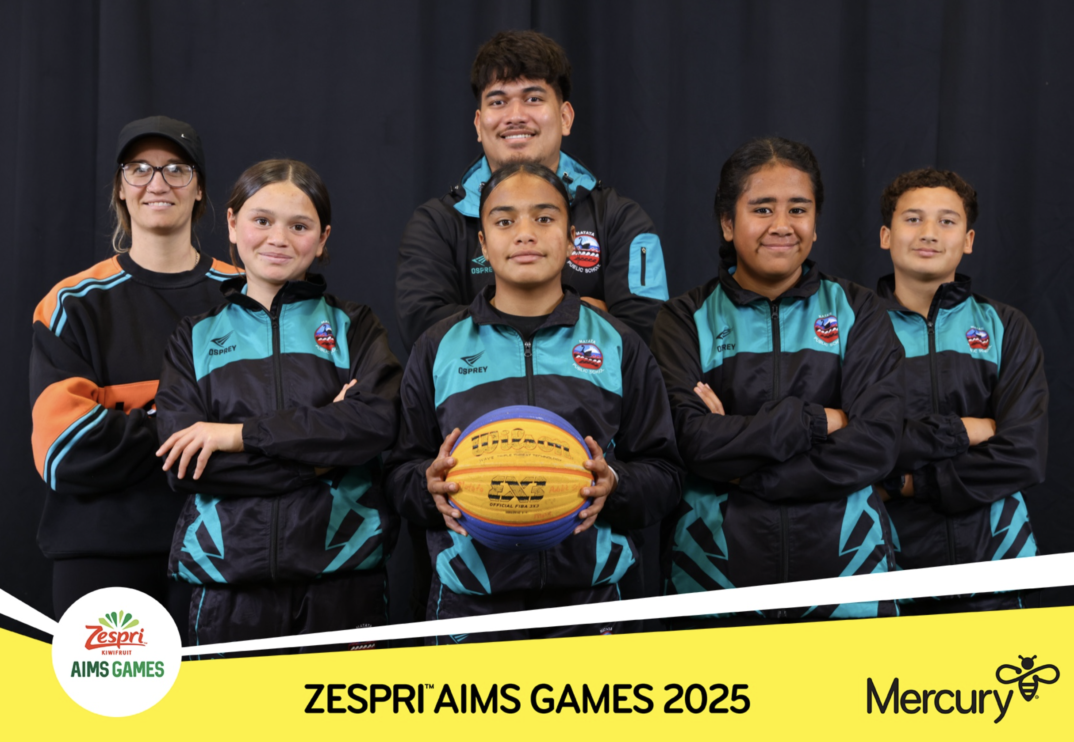
Our tamariki have had lots of fun this week learning how to roller-skate with the Skate Team.
It’s awesome seeing them get into it & give it a go.
We still have a couple of events left for the term,
EBOP Volleyball & Gutter board next week & AG Day in the last week.

KOTAHI VALUES
Our Kotahi Values focus for this term is “KO”
K = Kia mana Motuhake – Being motivated achievers
O = Owning our Learning and actions – Powerful Learners
Ko te manu e kai ana te miro nona te ngahere,
Ko te manu e kai ana te matauranga nona te ao!
The forest belongs to the bird that feasts on the berries,
The world belongs to the bird that feasts on knowledge!
Regarding school uniform -
School Uniform tops are available in the office for $15.
Any tidy black pants/shorts etc for the bottom half is fine.
Please ensure you like us on Facebook and sign up to the Skool Loop App( details below) to keep in touch with what is happening here at school.
We also have group chats for each class on Facebook Messenger.
If you are not in your child’s class “Messenger Group” please see their teacher and become part of the class chat as teachers are using this for reminders and as a way of contacting parents/caregivers. We do try and keep you informed on events taking place at school and the electronic way seems to be the best way to reach you all. If you do not use Facebook, Messenger or Skool Loop then please ensure you keep in touch with the school so we can get information to you on events concerning your child/ren.
Have a great weekend,
Tania Raynes – Principal

We would like to acknowledge and thank our Valued School Sponsors
garyfowell@xtra.co.nz
mayfairpools.co.nz/dealers/whakatane
07 - 307 0878

Core Plumbing Services
2 Willow Lane
Edgecumbe, Bay Of Plenty 3192
info@coreplumbingservices.co.nz
0226270751
Gareth Edwards
Omega Electrical
02041835405
Newsletter Sponsors:
Matata Bluelight, Ricoh, Crossroads Roading Contractors, Matthew Stephenson – Harcourts, Culham Engineering & Bunnings


Upcoming Events/Activities

Sept 10th & 11th – ERO here
( Education Review Office)
Sept 11th – EBOP Volleyball
Sept 12th – EBOP Gutter board

Sept 17th – Ag Day
Sept 18th – Last day of term

Sept 19th – Teacher only day
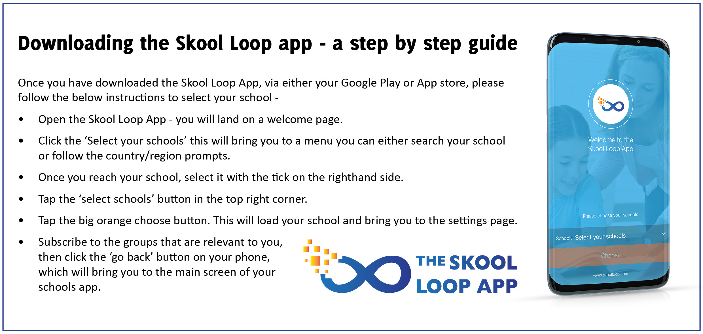
Absentees:
If your child is absent please send a message via skool loop or phone or email the school to advise or text your child’s teacher – remember to give a reason for an absence. Our absentee records go to the Ministry of Education now so we would rather put a genuine reason than an unknown absence.

Matata Public School Bank Account:
12 3253-0080452-00
Please use student name and a description as a reference when depositing.
eg: Jack – uniform.

School Uniform:
Uniform tops can be purchased from the School Office for $15.00 each (sizes 4-14).
Larger sizes we have purchased from another supplier are $25.00

