**Term 4 Week 1**

**10/10/2025**

Totara College

News

**This Term at Totara**

**Theme:**

All things Dannevirke

Value: Integrity

Kindnessss

**Scripture:**

“And seek the peace of the city where I have caused you to be carried away captive, and pray to the LORD for it: for in its peace you will have peace.”

***Vision***

*Reaching our God given Potential*



**From the Dr’s Office…**

Greetings everyone and welcome to the new term. Like always, it is packed with activities as well as a clear focus on learning and will be over before we know it. A brief run down of what’s in store:

* We welcome a new staff member to the school: **Mrs Angel Ashburner** who will be assisting students in Year 7-13 with their Mathematics this term. We are very fortunate to have Angel with us, she has experience in teacher-aiding and has a bachelor’s degree in mathematics.
* Next week will be a **professional development** (PD) focus for those in primary. Monday and Tuesday will see the Teachers of LC 1, 2 and 3 at a developing literacy PD event in Palmerston North and on Friday we have a visiting specialist teacher from the Kahui Ako to assist these teachers with their Art practice. (The Kahui Ako is our group of schools which come together, funded by the Ministry of Education, to improve practice. This funding is disappearing at the end of this year and so we are trying to leverage as much as we can before it goes.) Please note classes next week will still run as normal but won’t be taught by their normal teacher for these three days.
* **Strike action** – this action does not involve our teachers since we are an area school and have a different contract.
* **Transition activities** for children will begin if they are changing class next year. The class groupings will be:
  + LC1 Years 0-2 Whaea Lisa
  + LC2 Years 3-5 Mrs Ryklief
  + LC3 Years 6-8 Mrs Timmins
  + LC4 Years 9-10
  + LC5 Years 11-13

Exceptions can certainly be catered for, so if you have specific needs, please don’t hesitate to let us know.

* **Enrolment meetings** for new students next year are currently happening.
* **Fundraising concert with DCB (Dannevirke Charity Band)** for the French immersion Tahiti trip is on next week (Saturday). Two performances: 2pm and 7pm. I genuinely think you will regret it if you don’t take the opportunity – it’s very cheap at $10. Get your tickets from the school office or from students on the trip. It may be your only chance to see Mr Greaves on the guitar and me on the drums (and I’m a vocalist too).
* **Musicals for both primary and secondary** are on in Week 4 and Mrs Peters is working very hard to facilitate this. Practices occur regularly!
* **Athletic sports** will happen in Week 5, and classes will have lessons preparing them for this.
* **Chemistry Level 2 NCEA external exam is on in Week 6**-this will be the first time our students are sitting national exams.
* **Year 9-13 student camp to Taupo in Week 7 Wednesday 19- Friday 21**. We’ll be in tents and will have two boats taking the students on ski biscuit rides.
* **Year 1-3 sports tabloids** with Dannevirke schools will occur in Week 7.
* **Swimming teaching** at Wai Splash on Fridays for Years 1-10 in Weeks 6-9.
* **Prizegiving**-End of year Thursday Week 10.
* **Splash planet** trip for the whole school Friday Week 10.

My thanks to all of you who submitted responses to the Strategic Community consultation. The Board met on Thursday to consider the responses and formulate the plan going ahead. We will also be sending out consultation on student individual needs in secondary, to plan our courses. Please look out for this – it will determine how we structure our timetable next year.

Finally advance notice: the Board and the Ministry have given me a **sabbatical** **for Term 1** next year, so Ruth Peters will be Acting Principal in my absence. I’ll be spending the time visiting schools to see how we can do things even better.

Best wishes

Peter

**Athletics Day 2025 – from LC3**

Maddie:  Athletics is a fun school event for everyone. My favourite event is discus. I’m excited and nervous for the day to come but I’m going to try my best to succeed.

Navallie: I am super excited for athletics because I love high jump. High jump is my favourite event. I will try hard to do the best I can.

Elizabeth: Every year in Term 4 the whole school practices for the school Athletics. So far, we have practiced shotput, discus, relay races, and it was fun. In my opinion, long jump is the best.

Jevarn: Yes, it's that time of year. THE SCHOOL ATHLETICS!! My goal is to bet my records from last year. It won't be easy but going to give my best effort.

William: I am looking forward to long jump because I enjoy it the most.  One year I even won it. I also enjoy 100 meters sprints. But I never can beat Jevarn.  Luckily, he’s my friend so I’ll cheer for him, lol.

Ivan: We have been practising at athletics every day. I'm really excited about the long jump and high jump because I'm good at them. I have been running at home because that's the only event that I find hard.

Lara: In LC3 we have been practicing for athletics. I am very excited to do the high jump because it's my favourite event. So, everyone, pencil in the date, 6th November. 

See you there!

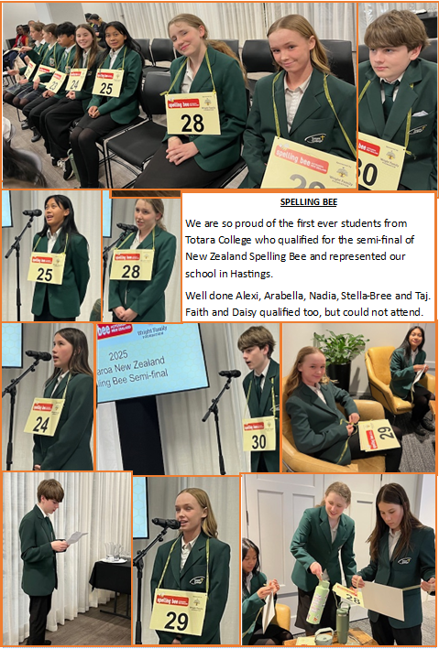

Fundraising

Totara College

The Fundraising Committee is run voluntarily by parents and staff of Totara College. We need more parents to come and help us out. Our current project is to replace the chairs in the hall. We have contacted the Dannevirke Regent Cinema to enquire about holding a movie fundraiser. They are more than happy for us to do this. **But we need parents to organise and run this for us.** We would like to hold the movie night in Term 4.

Please contact Danielle in the Office if you are able to help out with this.

**October Events**

|  |  |  |  |  |  |
| --- | --- | --- | --- | --- | --- |
| Monday | Tuesday | Wednesday | Thursday | Friday | Weekend |
|  |  | 1  Holidays | 2  Holidays | 3  Holidays | 4 & 5 |
| 6  Term Begins | 7 | 8 | 9 | 10 | 00 & 12 |
| 13 | 14 | 15 | 16 | 17 | 18 & 19  18th Dannevirke Charity Band  2pm and 7pm |
| 20 | 21 | 22 | 23 | 24 | 25 & 26 |
| 27  Labour Day | 28 | 29 | 30  School Musical  7pm | 31  School Musical  11am & 1pm |  |

**Term Dates**

Term 4: Monday 6 October – Friday 12 December

