Weekly Newsletter | Week 9| Term 4 | 2024

Morena Te Mata Whanau,
This week we have our student led conferences. These are always an amazing opportunity for your child to share their learning with you. Children have had a range of exciting activities and learning to share with you about the 2024 academic year.
I understand that some parents and students will be wondering about classes for 2025. Next year we are being allocated two new learning spaces by the MOE. This has been a number of years in the process but we have finally been informed that they should be here towards the end of 2025. Therefore we have made changes to our classrooms and will be opening seven classes next year. This supports the learning in all classes by keeping numbers smaller across the school. This teacher will be announced when all the documentation has been completed. This is an exciting time for Te Mata School.
Please remember that school closes for instruction at 12.30 on Thursday.
Nga Mihi Nui,
Fiona Gott
(Tumuaki)

  
  
  

Student Led Conferences
Student Led Conferences are this week. We look forward to seeing you on Thursday to celebrate your child’s successes over the year. School closes at 12.30 on Thursday for conferences. The Raglan Taxi Bus is leaving at that time all other MOE buses leave at the normal time. If you require supervision for your child please let me know fionag@temataraglan.school.nz

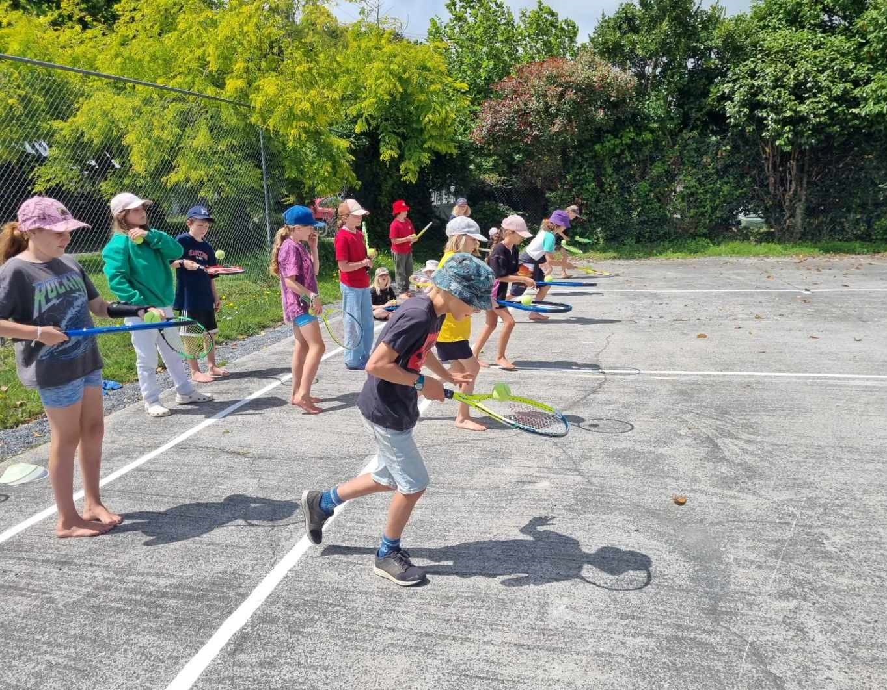
Tennis Lessons
Our wonderful Te Mata Tennis Club group has sponsored tennis lessons for Mango and Haku students. Thank you for this amazing opportunity for children to give tennis a go.

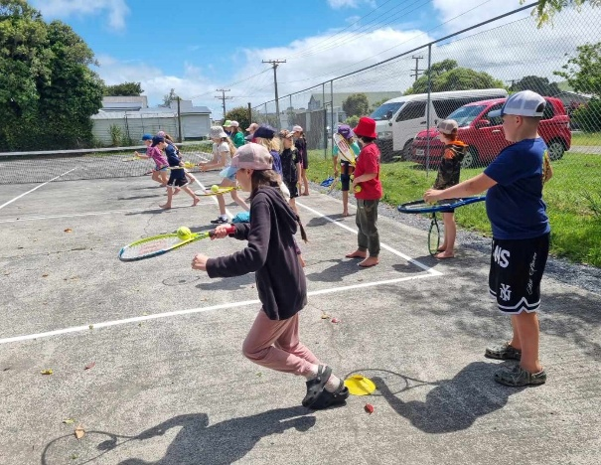
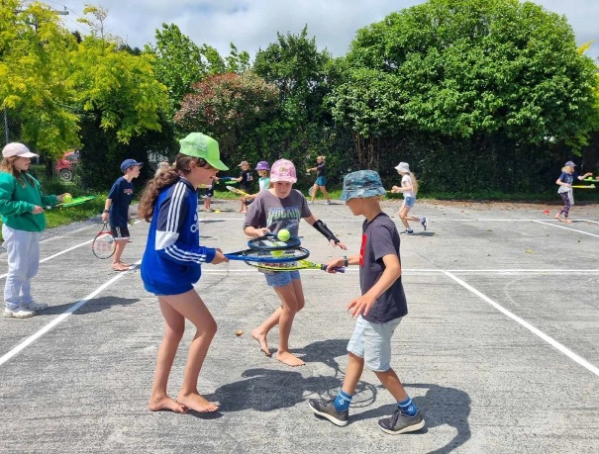

Whaea Lucy exciting news!
Whaea Lucy is taking an exciting opportunity for her family next year and will be taking a year away to travel. We wish her an exciting adventure and thank her for all the outstanding learning she has supported Te Mata students with. Lucy has been Kaataha classroom teacher with Whaea Alice and has also been our Structured Literacy intervention teacher. We will be announcing next week our appointment for Kaataha classroom teacher in 2025, their paperwork is being completed. Whaea Amy will be taking on the role of Structured Literacy intervention teacher for 2025.


Next Week
Our seniors have their Year 8 leavers trip to Ninja Valley, I am sure they will have lots of fun.
The final week of our 2024 academic year is next week. We have our final assembly at 11am in the Te Mata Hall on Wednesday 18th December. We look forward to seeing whanau to farewell our Y8 leavers.
Our last day is Friday 20th December 2024 and school closes at 1pm.

Counsellor 2025
Our school counsellor is a Board Of Trustees funded position in response to our community consultation feedback. We know that you value the service that having a councillor attend school one day a week can provide to some of our tamariki and whanau. Next year we have appointed Cathy Trueman as counsellor for 2025. Cathy will fill the role that Erika Smit (councillor until end of term 2) and Amy Hanna, pastoral care teacher term three and four had been fulfilling. Welcome to the Te Mata Team for 2025 Cathy!



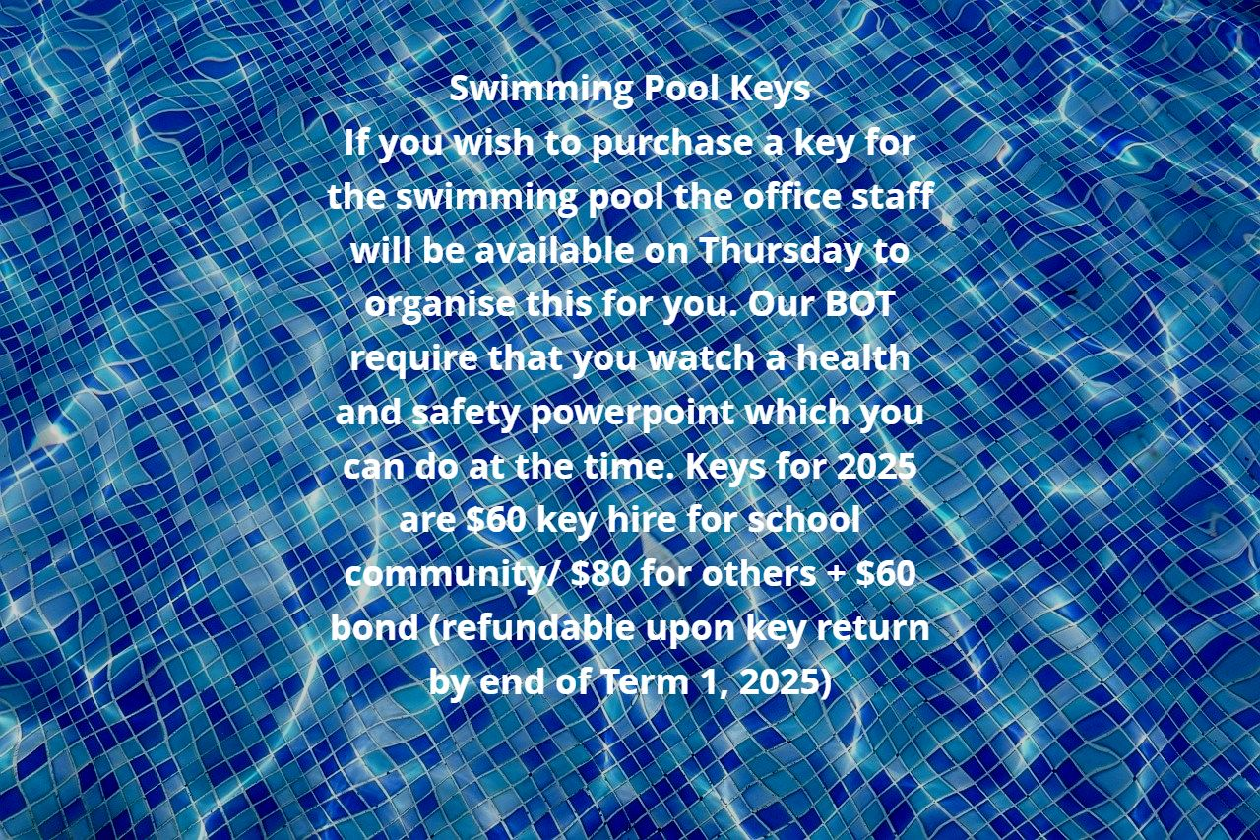

Library Books and Reading Books

Can all reading books and library books be returned by Friday 13th December. This allows time for them to be audited before the end of the year.



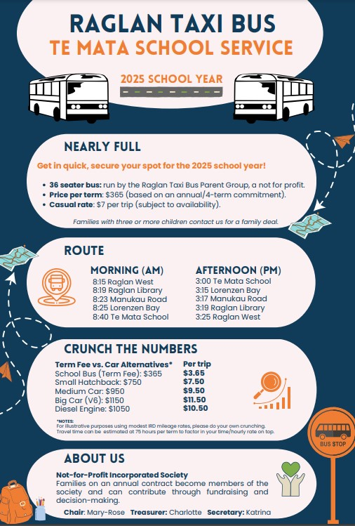

The following are our term dates for 2025:
Term One - 7th February - 11th April
Term Two - 28th April - 27th June
Term Three- 14th July - 19th September
Term Four - 6th October - 19th December

