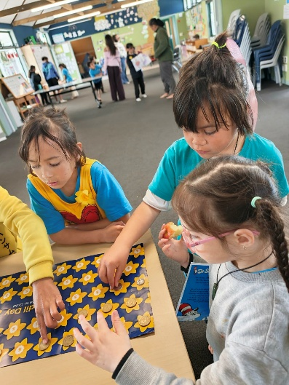
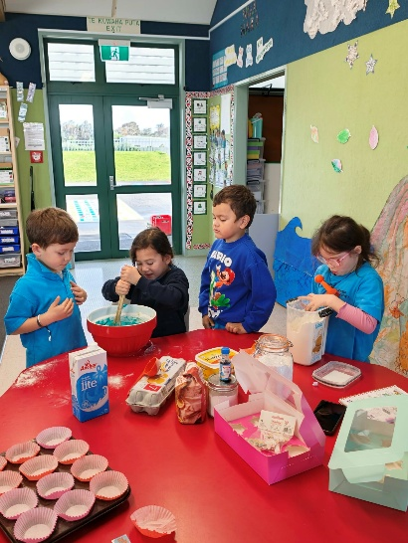
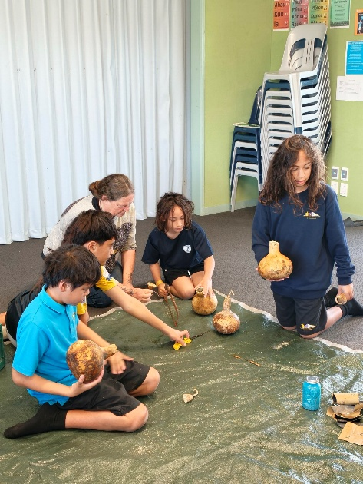
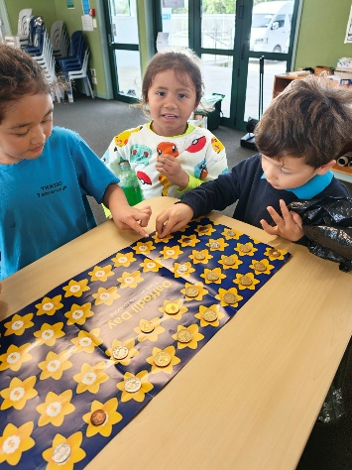

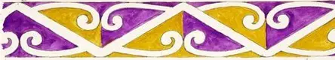
7th September – 35th Birthday planning 3:30 pm
21st September – BOT hui 5:00 pm
24th September – Whanau afternoon
- A Parent Survey was emailed out. Please fill them in so we can get as much feedback as possible. It is anonymous.
- Matua Lukey – he comes every Thursday for kapa haka tutoring.
- Daffodil Day – Thank you to everyone who brought in a gold coin. We raised $27.50 for the cause.

HUI / NOTICES
2nd September – Whaea Robyn, Koro John and Tuakana attending Koroneihana 2-5th
4th September – Tau 0-4 attending Hollard’s Garden
8th September – Touch starts for tau 3-8.
10th September – Attend Tātarakihi for the day
11th September – Kura attending Palmerston North Museum for the Air Play exhibition
25th September – Last day of term 3
12th October – First day of Term 4
DATES FOR TERM THREE
Touch begins this term and continues into term 4.
Tau 3-4 team is…We need a couch and ref.
O’shen
Raiden
Eli
TeArahi
Wairere
Taisyn
Hinewai
Ezrah

Tau 7-8 team will join Rahotu due to low numbers. Need a couch.
Adediz
Minnie
Manaaki
Kahn

SPORTS
Term 3 Newsletter

